NOTICES

THIS WEEK
Tuesday 3rd February
2.00pm Mothers’ Union Annual General Meeting at St Illtud’s Church, Llantwit Major
7.00pm Orthodox Vespers at St Illtud’s Church
Wednesday 4th February
10.00am Eucharist at St Illtud’s Church
11.00am Eucharist at St Tathan Church, St Athan
3.00pm Eucharist at All Saints Church, Southerndown
Thursday 5th February
10.00am Tiny Treasure Seekers at St Illtud’s Church
10.15am Community Worship at Wick & Marcross Church in Wales Primary School
2.00pm Seasons at St Illtud’s Church
3.00pm Short Cut Café at St Tathan Church
7.30pm Bell Ringing Practice at St Illtud’s Church
Friday 6th February
12.15pm Eucharist & soup lunch at St Illtud’s Church
6.00pm ‘Club Illtud’ in St Illtud’s Church
7.30pm Open Mic at St Illtud’s Church
Sunday 8th February: The Second Sunday before Lent: Creation Sunday
8.00am Eucharist at St Illtud’s Church, Llantwit Major
9.30am Eucharist at Ewenny Priory Church
9.30am Eucharist at St Illtud’s Church (& on Facebook)
9.30am Eucharist at St Mary Magdalene Church, Monknash
11.00am Eucharist at St Tathan Church, St Athan
11.00am Eucharist at St Bridget’s Church, St Brides Major
11.00am Eucharist at St Cattwg’s Church, Llanmaes
11.00am Eucharist at St James Church, Wick
11.15am Eucharist at St Donat’s Church, St Donat’s


Please take this leaflet home with you

Parish Office, St Illtud’s Church,
Church Street, LLantwit Major, CF61 1SB 01446 792439 office@ghcp.church

Material used is from Church in Wales Publications.
The Glamorgan Heritage Coast Ministry Area
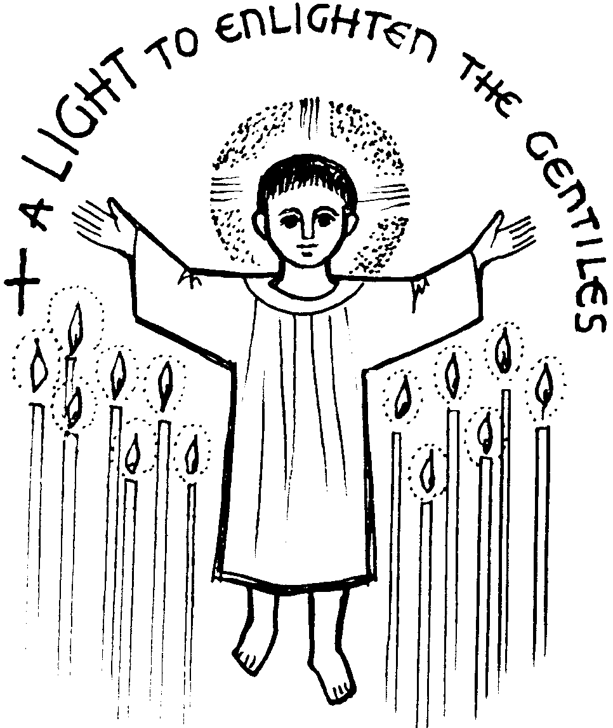
The Presentation of Christ: Candlemas

Collect
Almighty and ever-living God,
clothed in majesty,
whose beloved Son was this day presented in the Temple,
in substance of our flesh:
grant that we may be presented to you
with pure and clean hearts,
by your Son Jesus Christ our Lord,
who is alive and reigns with you,
in the unity of the Holy Spirit,
one God, now and for ever. Amen.
A reading from Malachi 3: 1-5
Thus says the Lord God: See, I am sending my messenger to prepare the way before me, and the Lord whom you seek will suddenly come to his temple. The messenger of the covenant in whom you delight indeed, he is coming, says the LORD of hosts. But who can endure the day of his coming, and who can stand when he appears? For he is like a refiner’s fire and like fullers’ soap; he will sit as a refiner and purifier of silver, and he will purify the descendants of Levi and refine them like gold and silver, until they present offerings to the LORD in righteousness. Then the offering of Judah and Jerusalem will be pleasing to the LORD as in the days of old and as in former years. Then I will draw near to you for judgement; I will be swift to bear witness against the sorcerers, against the adulterers, against those who swear falsely, against those who oppress the hired workers in their wages, the widow, and the orphan, against those who thrust aside the alien, and do not fear me, says the LORD of hosts.
Hear what the Spirit is saying to the Church: Thanks be to God

Psalm 24: 7-10
Response: Who is the King of glory? It is the Lord.
Lift up your heads, O gates: lift them high, ever lasting doors; and the King of glory shall come in. R: Who is the King of glory? It is the Lord.
‘Who is this King of glory?’
‘The Lord, strong and mighty:
the Lord, mighty in battle’
R: Who is the King of glory? It is the Lord.

Lift up your heads, O gates:
lift them high, O everlasting doors;
and the King of glory shall come in.
R: Who is the King of glory? It is the Lord.

‘Who is he, this King of glory?’
‘the Lord of hosts,
he is the King of glory’
R: Who is the King of glory? It is the Lord.

Gospel: Luke 2: 22-40
Alleluia, Alleluia
This is a light to reveal God to the nations
and the glory of his people Israel.
Alleluia

Listen to the Gospel of Christ according to St Luke: Glory to you, O Lord.

When the time came for their purification according to the law of Moses, Mary and Joseph brought Jesus up to Jerusalem to present him to the Lord. (as it is written in the law of the Lord,
‘Every firstborn male shall be designated as holy to the Lord’), and they offered a sacrifice according to what is stated in the law of the Lord, ‘a pair of turtle-doves or two young pigeons.’
Now there was a man in Jerusalem whose name was Simeon; this man was righteous and devout, looking forward to the consolation of Israel, and the Holy Spirit rested on him. It had been revealed to him by the Holy Spirit that he would not see death before he had seen the Lord’s Messiah.
Guided by the Spirit, Simeon came into the temple; and when the parents brought in the child Jesus, to do for him what was customary under the law, Simeon took him in his arms and praised God, saying, ‘Master, now you are dismissing your servant in peace, according to your word; for my eyes have seen your salvation, which you have prepared in the presence of all peoples, a light for revelation to the Gentiles and for glory to your people Israel.’
And the child’s father and mother were amazed at what was being said about him. Then Simeon blessed them and said to his mother Mary, ‘This child is destined for the falling and the rising of many in Israel, and to be a sign that will be opposed so that the inner thoughts of many will be revealed and a sword will pierce your own soul too.’
There was also a prophet, Anna the daughter of Phanuel, of the tribe of Asher. She was of a great age, having lived with her husband seven years after her marriage, then as a widow to the age of eighty-four. She never left the temple but worshipped there with fasting and prayer night and day. At that moment she came, and began to praise God and to speak about the child to all who were looking for the redemption of Jerusalem.
When they had finished everything required by the law of the Lord, they returned to Galilee, to their own town of Nazareth.
The child grew and became strong, filled with wisdom; and the favour of God was upon him.

This is the Gospel of the Lord: Praise to you O Christ.

Prayer over the Gifts:
Heavenly Father,
as your Son Jesus Christ
was presented in the temple,
let our offering today be acceptable to you
and grant that we may see in him,
who is our salvation,
the glory of your people
and the light of all nations,
who is alive and reigns, now and for ever.

Preface

through Jesus Christ your only Son our Lord, who shares your eternal splendour and was presented in the Temple. He was revealed by the Spirit as the glory of Israel that all peoples might find in him the light of the world.
Post Communion Prayer:
Lord, you filled the hope of Simeon and Anna,
who lived to welcome the Messiah; may we, who have received these gifts beyond words,
prepare to meet Christ Jesus when he comes
to bring us to eternal life;
for he is alive and reigns, now and for ever. Amen.

