NOTICES

THIS WEEK
There are no weekday services this week

Sunday 12th April: The Second Sunday of Easter
8.00am Eucharist at St Illtud’s Church, Llantwit Major
9.30am Eucharist at Ewenny Priory Church
9.30am Eucharist at St Illtud’s Church (& on Facebook)
11.00am Eucharist at St Bridget’s Church, St Brides Major
11.00am Eucharist at St Cattwg’s Church, Llanmaes
11.00am Eucharist at St James Church, Wick
11.00am Eucharist at St Tathan Church, St Athan
11.15am Eucharist at St Donat’s Church, St Donats

Please take this leaflet home with you


Parish Office, St Illtud’s Church,
Church Street, LLantwit Major, CF61 1SB 01446 792439 office@ghcp.church

Material used is from Church in Wales Publications.
The Glamorgan Heritage Coast Ministry Area
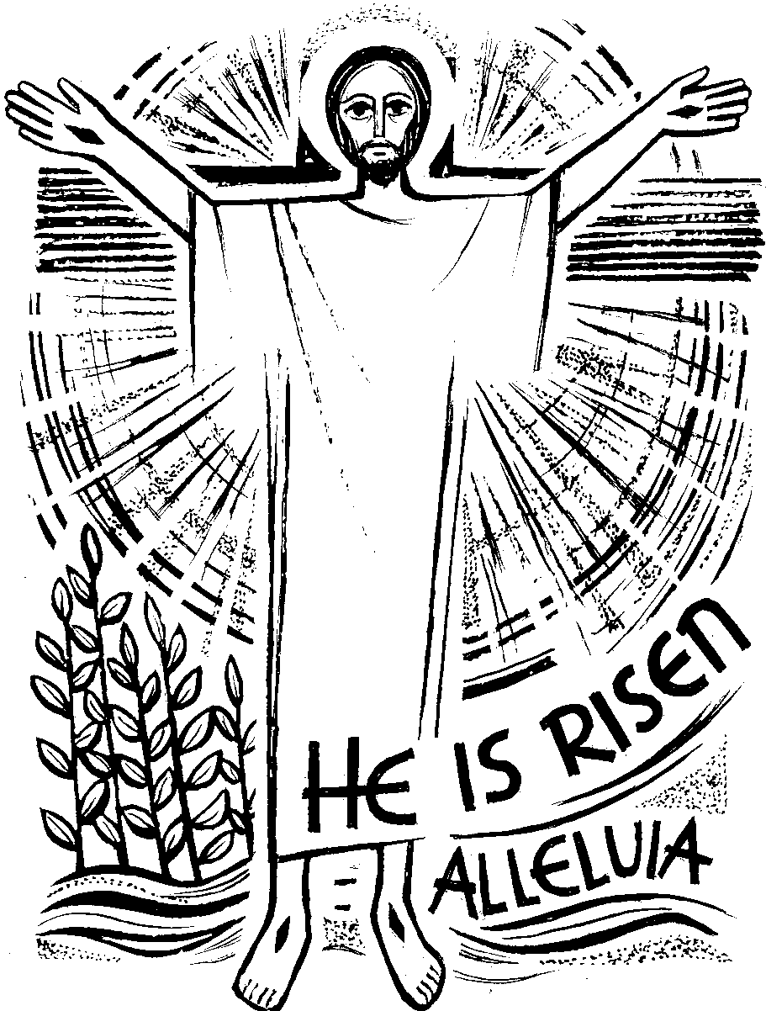
Easter Day

Collect Lord of all life and power, who through the resurrection of your Son overcame the old order of sin and death to make all things new in him: Grant that we, being dead to sin and alive to you in Jesus Christ, may reign with him in glory; to whom with you and the Holy Spirit be praise and honour, glory and might, now and in all eternity. Amen
A reading from Acts 10:34a, 37-43
Peter proceeded to speak and said:
"You know what has happened all over Judea,
beginning in Galilee after the baptism that John preached, how God anointed Jesus of Nazareth with the Holy Spirit and power. He went about doing good and healing all those oppressed by the devil,
for God was with him. We are witnesses of all that he did both in the country of the Jews and in Jerusalem.
They put him to death by hanging him on a tree. This man God raised on the third day and granted that he be visible, not to all the people, but to us, the witnesses chosen by God in advance, who ate and drank with him after he rose from the dead. He commissioned us to preach to the people and testify that he is the one appointed by God as judge of the living and the dead. To him all the prophets bear witness, that everyone who believes in him will receive forgiveness of sins through his name."
Hear what the Spirit is saying to the Church: Thanks be to God

Psalm 118:1-2, 16-17, 22-23
Response: Rejoice and be glad, Alleluia.
Give thanks to the LORD, for he is good,
his mercy endures forever.
Let the house of Israel now proclaim,
"His mercy endures forever." The Lord is my strength and my song, and has become my salvation. R: Rejoice and be glad, Alleluia.
There is a sound of exultation and
victory in the tents of the righteous
"The right hand of the LORD has struck with power;
the right hand of the LORD is exalted.
I shall not die, but live,
and declare the works of the LORD." R: Rejoice and be glad, Alleluia.

The stone which the builders rejected
has become the cornerstone.
By the LORD has this been done;
it is wonderful in our eyes. On this day the lord has acted. We will be glad and rejoice in it! R: Rejoice and be glad, Alleluia.
Gospel: John 20: 1-18
Alleluia! Alleluia! Christ our passover is sacrificed for us! Therefore let us keep the feast! Alleluia!
Listen to the Gospel of Christ according to St John, Alleluia!: Glory to you, O Lord, Alleluia
On the first day of the week, Mary of Magdala came to the tomb early in the morning, while it was still dark, and saw the stone removed from the tomb. So she ran and went to Simon Peter and to the other disciple whom Jesus loved, and told them,
"They have taken the Lord from the tomb, and we don't know where they put him."
So Peter and the other disciple went out and came to the tomb. They both ran, but the other disciple ran faster than Peter and arrived at the tomb first; he bent down and saw the burial cloths there, but did not go in.
When Simon Peter arrived after him, he went into the tomb and saw the burial cloths there, and the cloth that had covered his head, not with the burial cloths but rolled up in a separate place. Then the other disciple also went in, the one who had arrived at the tomb first, and he saw and believed. For they did not yet understand the scripture that he had to rise from the dead.
Then the disciples returned home. But Mary stayed outside the tomb weeping. And as she wept, she bent over into the tomb and saw two angels in white sitting there, one at the head and one at the feet where the body of Jesus had been. And they said to her, "Woman, why are you weeping?" She said to them, "They have taken my Lord, and I don't know where they laid him."
When she had said this, she turned around and saw Jesus there, but did not know it was Jesus. Jesus said to her, "Woman, why are you weeping? Whom are you looking for?" She thought it was the gardener and said to him, "Sir, if you carried him away, tell me where you laid him, and I will take him."
Jesus said to her, "Mary!" She turned and said to him in Hebrew, "Rabbouni," which means Teacher.
Jesus said to her, "Stop holding on to me, for I have not yet ascended to the Father. But go to my brothers and tell them, 'I am going to my Father and your Father, to my God and your God.'"
Mary of Magdala went and announced to the disciples, "I have seen the Lord," and what he told her.

This is the Gospel of the Lord, Alleluia!: Praise to you O Christ, Alleluia!

Prayer over the Gifts
Risen Lord Jesus Christ, we believe you, and all we have heard is true. When you break bread may we recognise you as the fire that burns within us that we may bring light to your world.
Preface

Because in his victory over death
a new age has dawned,
the long reign of sin has ended,
a broken world is being renewed
and we are once again made whole.

Post Communion Prayer

God of life,
who for our redemption
gave your only-begotten Son
to the death of the Cross,
and by his glorious Resurrection
have delivered us
from the power of our enemy:
grant us so to die daily unto sin
that we may evermore live with him
in the joy of his risen life;
though Jesus Christ our Lord. Amen

