NOTICES
THIS WEEK
Wednesday 20th May
10.00am Eucharist at St Illtud’s Church
11.00am Eucharist at St Tathan Church, St Athan
3.00pm Eucharist at All Saints Church, Southerndown
Thursday 21st May
10.00am Tiny Treasure Seekers at St Illtud’s Church
2.00pm Seasons at St Illtud’s Church
3.00pm Short Cut Café at St Tathan Church 7.30pm Bell Ringing Practice at St Illtud’s Church
Friday 22nd May
12.15pm Eucharist & soup lunch at St Illtud’s Church
2.30pm Community Worship for Pentecost at Wick & Marcross Church in Wales Primary School
6.00pm ‘Club Illtud’ in St Illtud’s Church
Sunday 24th May: The Day of Pentecost
8.00am Eucharist at St Illtud’s Church, Llantwit Major
9.30am Eucharist at Ewenny Priory Church
9.30am Eucharist at St Illtud’s Church (& on Facebook)
11.00am Eucharist at St Bridget’s Church, St Brides Major
11.00am Eucharist at St Cattwg’s Church, Llanmaes
11.00am Eucharist at St James Church, Wick
11.15am Prayer & Praise at St Donat’s Church, St Donats
6.30pm Compline at St Illtud’s Church

Please take this leaflet home with you


Parish Office, St Illtud’s Church,
Church Street, LLantwit Major, CF61 1SB 01446 792439 office@ghcp.church

Material used is from Church in Wales Publications.
The Glamorgan Heritage Coast Ministry Area
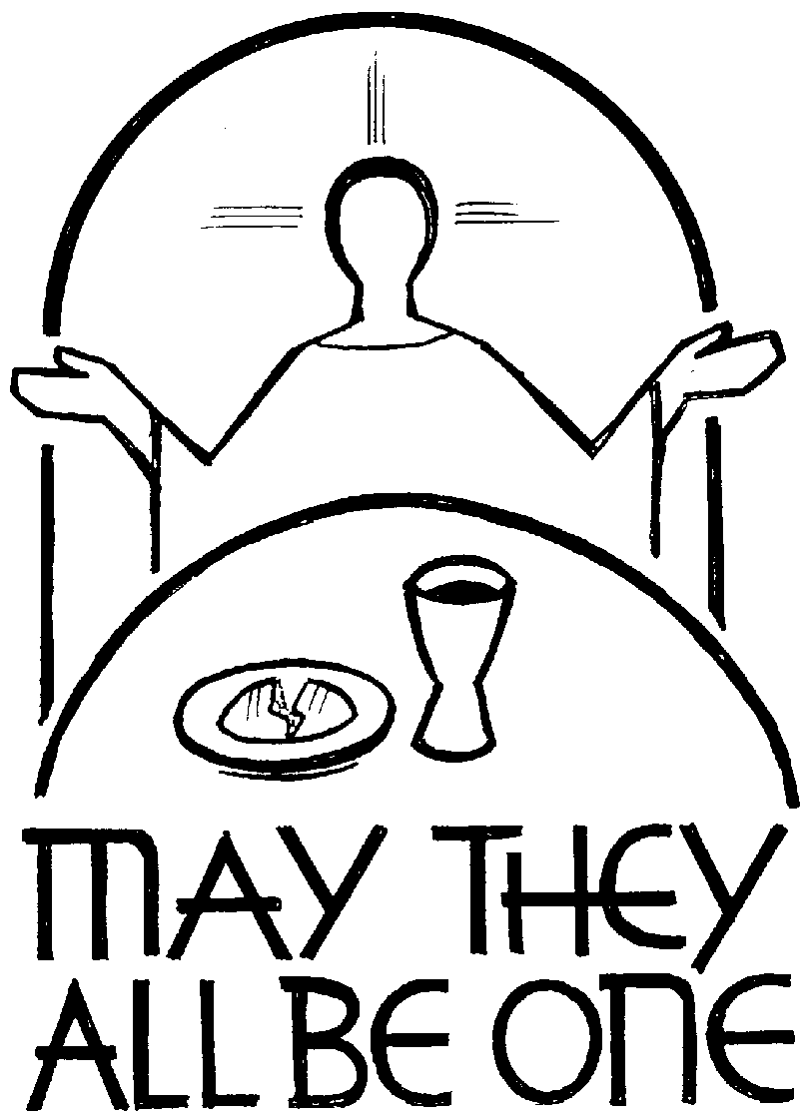
The Seventh Sunday of Easter

Collect
O God the King of glory,
you have exalted your only Son Jesus Christ
with great triumph to your kingdom in heaven:
we beseech you, leave us not comfortless,
but send your Holy Spirit to strengthen us
and exalt us to the place where our Saviour Christ is gone before,
who is alive and reigns with you,
in the unity of the Holy Spirit,
one God, now and for ever. Amen.
A reading from Acts 1: 6-14
When the apostles had come together, they asked him, ‘Lord, is this the time when you will restore the kingdom to Israel?’ He replied, ‘It is not for you to know the times or periods that the Father has set by his own authority. But you will receive power when the Holy Spirit has come upon you; and you will be my witnesses in Jerusalem, in all Judea and Samaria, and to the ends of the earth.’
When he had said this, as they were watching, he was lifted up, and a cloud took him out of their sight. While he was going and they were gazing up towards heaven, suddenly two men in white robes stood by them. They said, ‘Men of Galilee, why do you stand looking up towards heaven? This Jesus, who has been taken up from you into heaven, will come in the same way as you saw him go into heaven.’ Then they returned to Jerusalem from the mount called Olivet, which is near Jerusalem, a sabbath day’s journey away. When they had entered the city, they went to the room upstairs where they were staying, Peter, and John, and James, and Andrew, Philip and Thomas, Bartholomew and Matthew, James son of Alphaeus, and Simon the Zealot, and Judas son of James. All these were constantly devoting themselves to prayer, together with certain women, including Mary the mother of Jesus, as well as his brothers.

Hear what the Spirit is saying to the Church: Thanks be to God

Psalm 68: 1-10, 32-35
Response: Alleluia! The God of Israel gives us strength and power.

Let God arise and let his enemies be scattered;
let those who hate him flee before him.
But let the righteous be glad and rejoice before God;
let them also be merry and joyful. R: Alleluia! The God of Israel gives us strength and power.

Sing to God, sing praises to his name;
exalt him who rides upon the heavens;
Father of orphans, defender of widows,
God in his holy habitation. R: Alleluia! The God of Israel gives us strength and power.

O God, when you went forth before your people,
the earth shook and the skies poured down rain.
But you sent a gracious rain upon your inheritance:
your people found their home in it. R: Alleluia! The God of Israel gives us strength and power.

Ascribe power to God,
his majesty is over Israel.
How wonderful is God in his holy places,
Bless’d be God! R: Alleluia! The God of Israel gives us strength and power.

Gospel: John 17: 1-11
Alleluia! Alleluia
If you love me, you will keep my word,
and the Father will love you,
and we will come to you
Alleluia!

Listen to the Gospel of Christ according to St John, Alleluia!: Glory to you, O Lord, Alleluia
Jesus looked up to heaven and said, ‘Father, the hour has come; glorify your Son so that the Son may glorify you, since you have given him authority over all people, to give eternal life to all whom you have given him. And this is eternal life, that they may know you, the only true God, and Jesus Christ whom you have sent. I glorified you on earth by finishing the work that you gave me to do. So now, Father, glorify me in your own presence with the glory that I had in your presence before the world existed.
I have made your name known to those whom you gave me from the world. They were yours, and you gave them to me, and they have kept your word. Now they know that everything you have given me is from you; for the words that you gave to me I have given to them, and they have received them and know in truth that I came from you; and they have believed that you sent me. I am asking on their behalf; I am not asking on behalf of the world, but on behalf of those whom you gave me, because they are yours. All mine are yours, and yours are mine; and I have been glorified in them. And now I am no longer in the world, but they are in the world, and I am coming to you. Holy Father, protect them in your name that you have given me, so that they may be one, as we are one.’

This is the Gospel of the Lord, Alleluia!: Praise to you O Christ, Alleluia!

Prayer over the Gifts
Father, by your Holy Spirit, hold the Church in unity and keep her faithful to your word,
so that, breaking bread together,
we may be one with Christ in faith and love and service,
for ever and ever.

Preface

Who after his resurrection showed himself to his apostles
and in their sight ascended into glory
to prepare a place for us, that where he is, we might also be.

Post Communion Prayer

Eternal God, giver of love and power, your Son Jesus Christ has sent us into all the world
to preach the gospel of his kingdom:
confirm us in this mission,
and help us to live the good news we proclaim;
through Jesus Christ our Lord. Amen

