NOTICES
Tuesday 1st September
2.00pm Mothers’ Union Meeting at St Illtud’s Church, Llantwit
7.00pm Orthodox Vespers in the Galilee Chapel
Wednesday 2nd September
10.00am Eucharist at St Illtud’s Church, Llantwit Major
11.00am Eucharist at St Tathan Church, St Athan
3.00pm Eucharist at All Saints Church, Southerndown
Thursday 3rd September
10.15am Community Worship at Wick & Marcross Church in Wales Primary School
11.00am Eucharist at Brocastle Manor Care Home
2.00pm Seasons at St Illtud’s Church
7.30pm Bellringers practice at St Illtud’s Church
Friday 4th September
12.15pm Eucharist & soup lunch at St Illtud’s Church
6.00pm ‘Club Illtud’ in St Illtud’s Church
Sunday 6th September: The Fourteenth Sunday after Trinity
8.00am Eucharist at St Illtud’s Church, Llantwit Major
9.30am Eucharist at Ewenny Priory Church
9.30am Eucharist at St Giles Church, Gileston
9.30am Eucharist at St Illtud’s Church (& on Facebook)
9.30am Eucharist at St Michael & All Angels Church, Llanmihangel
11.00am Eucharist at St Bridget’s Church, St Brides Major
11.00am Eucharist at St Cattwg’s Church, Llanmaes
11.00am Eucharist at St James Church, Wick
11.15am Prayer & Praise at St Donat’s Church
6.00pm Eucharist at Holy Trinity Church, Marcross

Please take this leaflet home with you

Parish Office, St Illtud’s Church,
Church Street, LLantwit Major, CF61 1SB 01446 792439 office@ghcp.church

Material used is from Church in Wales Publications.
The Glamorgan Heritage Coast Ministry Area
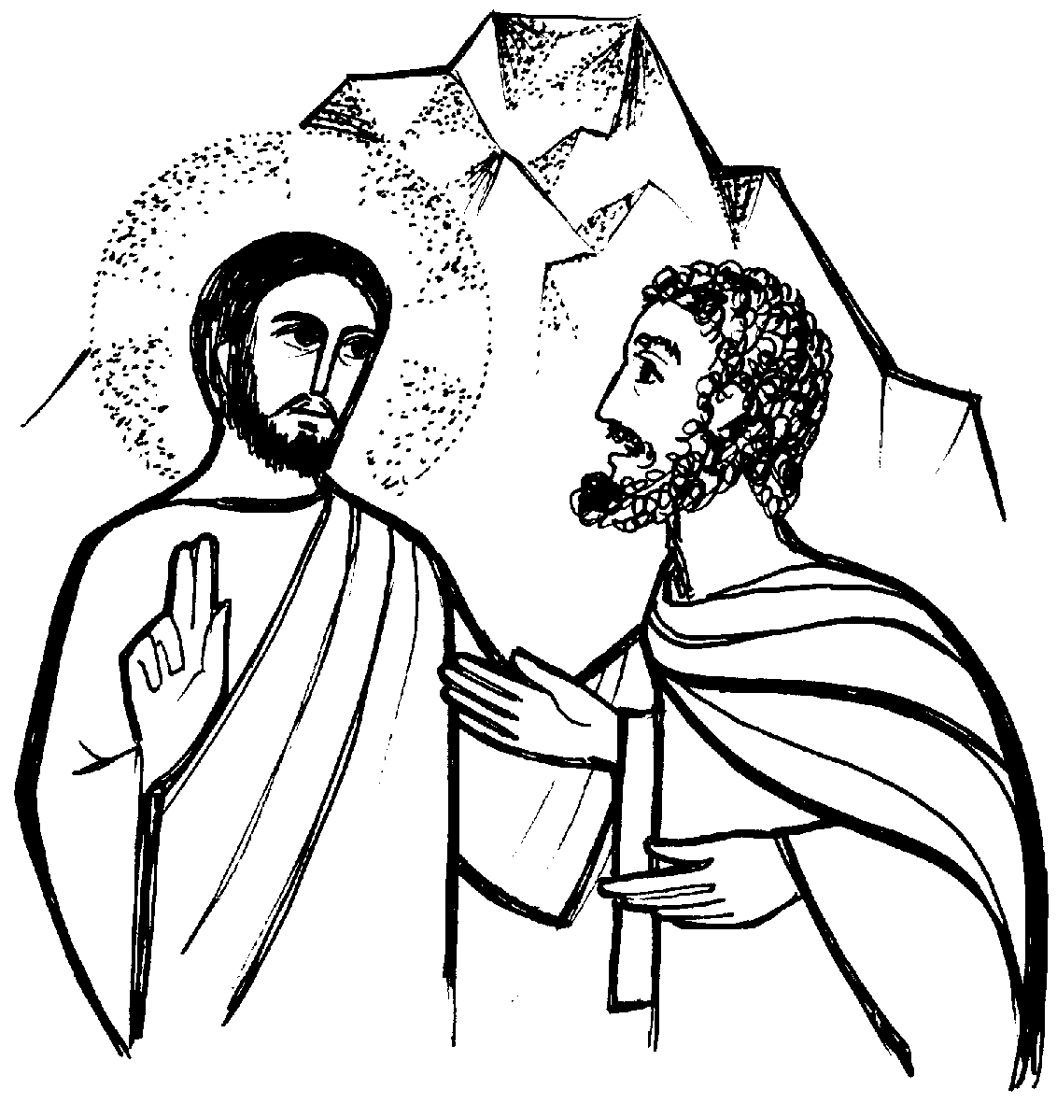
The Thirteenth Sunday after Trinity

Collect

Almighty God, you called your Church to bear witness
that you were in Christ reconciling the world to yourself:
help us to proclaim the good news of your love,
that all who hear it may be drawn to you;
through him who was lifted up on the cross,
and reigns with you in the unity of the Holy Spirit,
one God, now and for ever. Amen

A reading from Romans 12: 9-21
Let love be genuine; hate what is evil, hold fast to what is good; Love one another with mutual affection; outdo one another in showing honour. Do not lag in zeal, be ardent in spirit, serve the Lord. Rejoice in hope, be patient in suffering, persevere in prayer. Contribute to the needs of the saints; extend hospitality to strangers.
Bless those who persecute you; bless and do not curse them. Rejoice with those who rejoice, weep with those who weep. Live in harmony with one another; do not be haughty, but associate with the lowly; do not claim to be wiser than you are. Do not repay anyone evil for evil, but take thought for what is noble in the sight of all. If it is possible, so far as it depends on you, live peaceably with all. Beloved, never avenge yourselves, but leave room for the wrath of God; for it is written, "Vengeance is mine, I will repay, says the Lord." No, "if your enemies are hungry, feed them; if they are thirsty, give them something to drink; for by doing this you will heap burning coals on their heads." Do not be overcome by evil, but overcome evil with good.

Hear what the Spirit is saying to the Church: Thanks be to God

Psalm 26: 1-8
Response: Lord, I love the place where your glory abides.

Give judgement for me, O Lord,
for I have trusted in you and have not faltered.
Test me, O Lord, and try me,
examine my heart and my mind. R: Lord, I love the place where your glory abides.

For your love is before my eyes,
I have walked faithfully with you.
I have hated the company of evildoers;
I will not sit down with the wicked. R: Lord, I love the place where your glory abides.

I will wash my hands in innocence, O Lord,
that I may go in procession round your altar,
Singing aloud a song of thanksgiving
and recounting all your wonderful deeds. R: Lord, I love the place where your glory abides.

Gospel: Matthew 16: 21-28
Alleluia! Alleluia!
Open our hearts, O Lord,
to accept the words of your Son
Alleluia!

Listen to the Gospel of Christ according to St Matthew: Glory to you, O Lord.
From that time on, Jesus began to show his disciples that he must go to Jerusalem and undergo great suffering at the hands of the elders and chief priests and scribes, and be killed, and on the third day be raised. And Peter took him aside and began to rebuke him, saying, "God forbid it, Lord! This must never happen to you." But he turned and said to Peter, "Get behind me, Satan! You are a stumbling block to me; for you are setting your mind not on divine things but on human things."
Then Jesus told his disciples, "If any want to become my followers, let them deny themselves and take up their cross and follow me. For those who want to save their life will lose it, and those who lose their life for my sake will find it. For what will it profit them if they gain the whole world but forfeit their life? Or what will they give in return for their life?
"For the Son of Man is to come with his angels in the glory of his Father, and then he will repay everyone for what has been done. Truly I tell you, there are some standing here who will not taste death before they see the Son of Man coming in his kingdom."

This is the Gospel of the Lord: Praise to you O Christ.

Prayer over the Gifts

Living host,
call us together to eat and drink with you;
grant that by your body and your blood
we may be drawn to each other and to you;
who are alive and reign, now and for ever.

Preface

For he is our great high priest
who has freed us from our sins
and has made us a royal priesthood
serving you, our God and Father.

Post Communion Prayer

God our creator, you feed your children with the true manna,
the living bread from heaven:
let this holy food
sustain us through our earthly pilgrimage
until we come to that place
where hunger and thirst are no more;
through Jesus Christ our Lord. Amen

