NOTICES
THIS WEEK
Tuesday 6th October
10.00am to 3.00pm Mothers’ Union Quiet Day at All Saints Church, Southerndown led by Richard & Storm Hann
7.00pm Orthodox Vespers in the Galilee Chapel
Wednesday 7th October
10.00am Eucharist at St Illtud’s Church
11.00am Eucharist at St Tathan Church, St Athan
3.00pm Eucharist at All Saints Church, Southerndown
Thursday 8th October
9.00am Community Worship at Wick & Marcross Church in Wales Primary School
10.00am Tiny Treasure Seekers at St Illtud’s Church
2.00pm Seasons at St Illtud’s Church
7.30pm Bellringers practice at St Illtud’s Church
Friday 9th October
12.15pm Eucharist & soup lunch at St Illtud’s Church
6.00pm ‘Club Illtud’ in St Illtud’s Church
Sunday 11th October: The Nineteenth Sunday after Trinity
8.00am Eucharist at St Illtud’s Church, Llantwit Major
9.30am Eucharist at Ewenny Priory Church
9.30am Eucharist at St Illtud’s Church (& on Facebook)
11.00am Harvest with St Brides Major Church in Wales Primary School at St Bridget’s Church, St Brides Major
11.00am Eucharist at St Cattwg’s Church, Llanmaes
11.00am Eucharist with Treasure Seekers at St James Church, Wick
11.00am Harvest Thanksgiving at St Tathan Church, St Athan
6.00pm Harvest Thanksgiving at St Mary Magdalene Church, Monknash

Please take this leaflet home with you


Parish Office, St Illtud’s Church,
Church Street, LLantwit Major, CF61 1SB 01446 792439 office@ghcp.church

Material used is from Church in Wales Publications.
The Glamorgan Heritage Coast Ministry Area
Thanksgiving for the Harvest
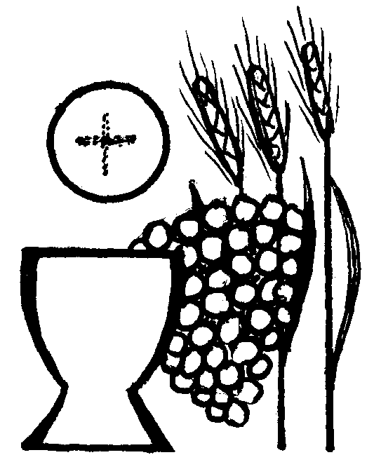

Collect
Almighty and everlasting God, we offer you our grateful thanks for your fatherly goodness and care in giving us your gifts and the fruits of the earth in through the seasons. Give us grace to use them rightly, to your glory, for our own well being, and for the relief of those in need; through Jesus Christ our Lord. Amen

A reading from 2 Corinthians 9: 6-15
The one who sows sparingly will also reap sparingly, and the one who sows bountifully will also reap bountifully. Each of you must give as you have made up your mind, not reluctantly or under compulsion, for God loves a cheerful giver. And God is able to provide you with every blessing in abundance, so that by always having enough of everything, you may share abundantly in every good work. As it is written, “He scatters abroad, he gives to the poor;
his righteousness endures forever.”
He who supplies seed to the sower and bread for food will supply and multiply your seed for sowing and increase the harvest of your righteousness. You will be enriched in every way for your great generosity, which will produce thanksgiving to God through us; for the rendering of this ministry not only supplies the needs of the saints but also overflows with many thanksgivings to God. Through the testing of this ministry you glorify God by your obedience to the confession of the gospel of Christ and by the generosity of your sharing with them and with all others, while they long for you and pray for you because of the surpassing grace of God that he has given you. Thanks be to God for his indescribable gift!
Hear what the Spirit is saying to the Church: Thanks be to God

Adapted portions from Psalm 65
Response: Let the whole earth shout out to God with Joy.
O God, it is right for us to praise you in Zion
and keep our promises to you,
because you answer prayers.
Happy are those whom you choose,
whom you bring to your sanctuary.
R: Let the whole earth shout out to God with Joy.
The whole world stands in awe
of the great things that you have done.
Your deeds bring shouts of joy
from one end of the earth to the other.
R: Let the whole earth shout out to God with Joy.

You show your care for the land by sending rain;
you make it rich and fertile.
What a rich harvest your goodness provides!
Wherever you go there is plenty.
Everything shouts and sings for joy.
R: Let the whole earth shout out to God with Joy.

Gospel: Luke 12: 22-30
Alleluia, Alleluia
“Strive first for the kingdom of God and his righteousness, and all these things will be given to you as well, says the Lord”
Alleluia

Listen to the Gospel of Christ according to Luke: Glory to you, O Lord.
He said to his disciples, “Therefore I tell you, do not worry about your life, what you will eat, or about your body, what you will wear. For life is more than food, and the body more than clothing. Consider the ravens: they neither sow nor reap, they have neither storehouse nor barn, and yet God feeds them. Of how much more value are you than the birds! And can any of you by worrying add a single hour to your span of life? If then you are not able to do so small a thing as that, why do you worry about the rest? Consider the lilies, how they grow: they neither toil nor spin; yet I tell you, even Solomon in all his glory was not clothed like one of these. But if God so clothes the grass of the field, which is alive today and tomorrow is thrown into the oven, how much more will he clothe you—you of little faith! And do not keep striving for what you are to eat and what you are to drink, and do not keep worrying. For it is the nations of the world that strive after all these things, and your Father knows that you need them.
This is the Gospel of the Lord: Praise to you O Christ.

Prayer over the Gifts:
O Lord Jesus Christ, who has taught us that we do not live on bread alone: Feed us, we humbly beseech you, with the true Bread that comes down from heaven, even yourself, O blessed Saviour.

Extended preface

And now we give you thanks
because you have given us the fruits of the earth
to feed and sustain us,
and in commanding us to keep this holy Eucharist, you sanctified the grain of the field and the fruit of the vine,
making it the bread of life and the cup of salvation.
You have gathered us, old and young, rich and poor,
male and female, as a harvest people, and called us to share our gifts to your glory.

Post Communion Prayer:
Lord of the harvest, in joy we have offered thanksgiving for your love in creation and have shared in the bread and the wine of the kingdom: by your grace plant within us a reverence for all that you give us and make us generous and wise stewards of the good things we enjoy; through Jesus Christ our Lord. Amen

Blessing

Lord, of the seedtime and the harvest,
you have blessed us with many things.
Send us from this place
further blessed and strengthened
so that we might live and grow
and bear good fruit to your praise and glory……

